- Sampling Frame for the rCARI Validation Study
Figure 1 below presents the generic sampling procedure that has been adopted for the study across the 3 countries so far. Selection of study area followed a 3-point criterium: phone coverage, accessibility, and food security situation. Phone coverage is important consideration for the remote interviews, while field accessibility ensures that enumerators can interview households in face-to-face modules. Food security consideration would ensure that at least areas that have different AFI (acute food insecurity) situations are represented in the study (not only one group being represented, i.e., either mainly food secure or food insecure households). In all the pilot countries, the same method was applied in identifying and selecting the broader study areas (Admin1).
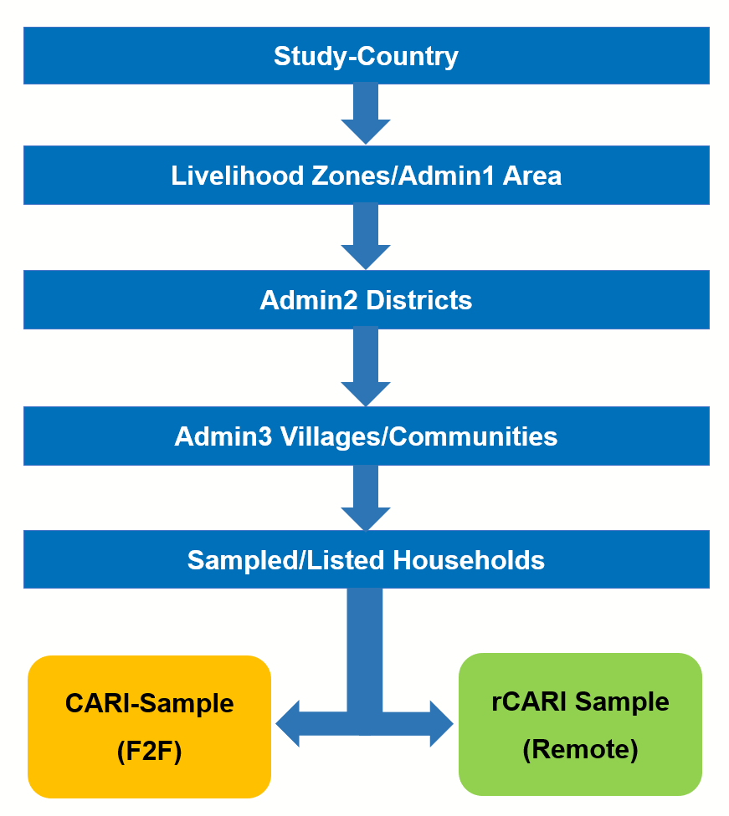
Figure 1: Sampling and Randomization Procedure
STEP 1 - Livelihood Zones/ADMIN1 Area Selection: A minimum of 2/3 Admin1 Areas were identified together with WFP CO based on phone coverage, food security situation and accessibility. If many Admin1 areas are available, a simple random sampling approach was used to select the 2/3 Admin1 Areas.
STEP 2 - ADMIN2 Selection: A minimum of 4 ADMIN2 areas were randomly selected (2 per ADMIN1 Area based on the outcome of Step 1).
STEP 3 - ADMIN5 (villages, communities, or camps) Areas: All ADMIN 5 (villages) in ADMIN2 that meets the inclusion criteria set out in STEP 1 are now compiled at this stage as the primary sampling units (PSUs). A total of 20 PSUs were randomly selected (distributed uniformly across the selected ADMIN1 AREAS) as sampling clusters to draw the households from.
STEP 4 - Sampled households: The sampling frame for the study was all households in selected PSUs. A minimum of 100 households per PSU were selected through the random-walk approach (listing every 3rd house in the sequence) by trained enumerators. Consent of participation was taken from all HHs before being included into the study sample. Based on the number of PSUs per country, 2000-2500HHs (except in Myanmar where the initial sample was 1,665HHs). The final listed households in this stage were used for the randomization process in the next step.
STEP 5 - Randomization of household (hh): Consented final sampled households in STEP 4 are randomly assigned into one of two survey modalities/groups; F2F (CARI group) and Remote (rCARI group). The designed is such that sample will be divided equally between the modalities. All interviews were conducted over the same time frame to ensure that households in the two modalities are reporting their food security situation over the same window.
  - Myanmar
In Myanmar, the study was implemented amongst IDPs (internally displaced persons) in two regions: Kachin and Shan (Admin 1). The sampling list was compiled using WFP beneficiaries made up of IDPs in the two regions. A total of 20 camps were selected randomly as the primary sampling units (PSU). All households in the selected camps formed the sampling frame for the study in Myanmar. A minimum of 100 households were then randomly selected from each camp for the study (However, because some of the camps had fewer than 100 households, the final sampled households were 1665 in total).
  - Ecuador
In Ecuador, the study was implemented in three regions: Amazonia, Coasta and Sierra (Admin1 areas). In addition to the standard selection criteria based on accessibility and food security prevalence, consideration was also given to the safety of the team, considering the political situation at the time of implementing the study.
A total of 27 Admin5 areas (villages) were randomly selected from the 3 Admin1 areas based on the foregoing criteria. These formed the PSUs for the study in Ecuador. All households in the selected 27 PSUs formed the selection frame and were eligible to be enlisted into the study. A total of 3220 households were listed (approximately 120 households per PSU were randomly selected) for the study in two phases.
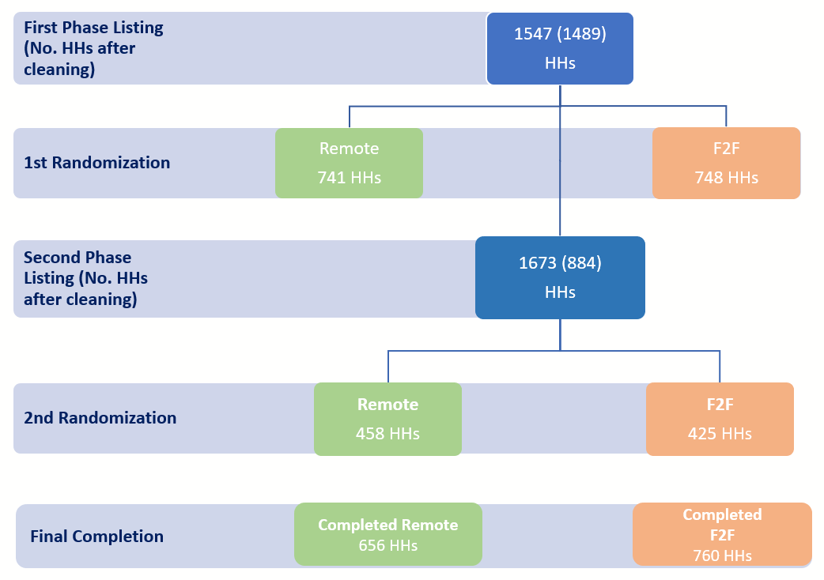
Figure 2: Sampling & randomization in Ecuador
  - Central African Republic (CAR)
Study in CAR was implemented in two Prefectures: Mbomou and Nana-Gribizi (he two most accessible areas (aside from Bangui) that also had a varying level of food security).
The selection of PSUs followed a similar pattern using field access (security situation) and mobile phone network coverage. The list of Admin5 areas that met the access and mobile phone coverage criteria formed the sampling frame. A total of 25 Admin5 areas (villages) were randomly selected from the list of Admin5 areas compiled jointly be the CAR CO and the local mobile phone service providers (to ensure that all Admin5 areas selected had mobile phone network). Admin5 areas without phone coverage were automatically excluded.
To ensure that the final sample was a mix of rural and urban households (taking into consideration there was a potentially different food security situation between rural and urban households), sub layer of locality was included during the selection of Admin5 areas so that the final sampled PSUs were a combination rural and urban areas.
The sampling frame for the study was all households in the 25 selected ADMIN5 areas. The listing phase was conducted through the random-walk methodology in each selected PSU by trained enumerators. A minimum of 100 households/respondents per PSU totalling 2500 households/respondents were listed as potential study participants. Phone numbers of the main respondent and any other phone numbers within the household that could have been used to contact the main respondent during the survey were collected. Drawing from the data collection experience in Myanmar and Ecuador, a number of demographic characteristics such as age of household head, gender of household head, household size, and ownership of common household assets was collected during household listing and used for the statistical balance test.
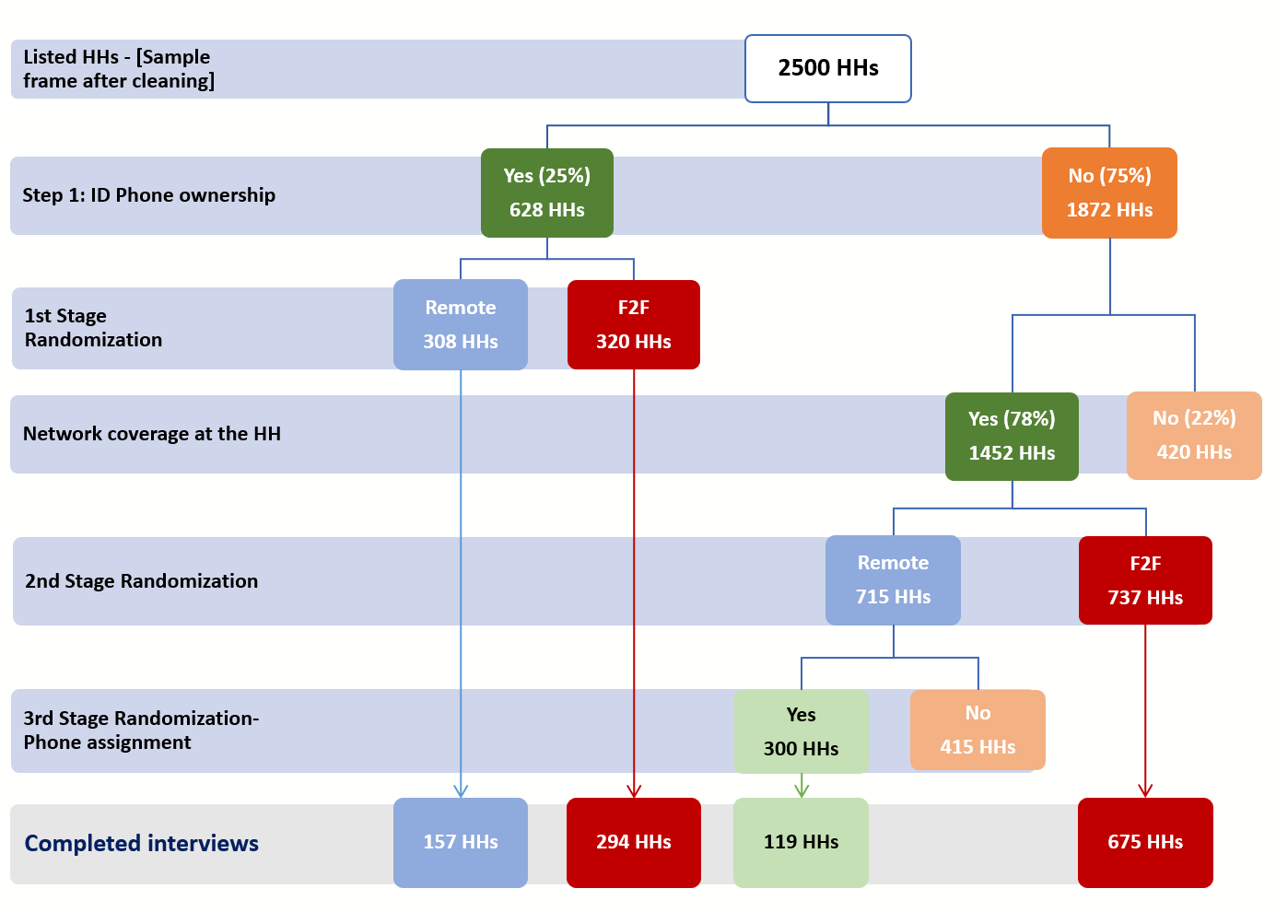
Figure 3: Sampling & randomization in CAR
  - Burkina Faso
The study will be implemented in two prefectures-Centro and North Prefectures of the country. 25 villages (Admin 5 areas) have been randomly selected as PSUs. All household in these PSUs would form the sampling frame of the study. Households would be enlisted into the study through household listing to be done using the random walk methodology, selecting every 3rd household in a systematic way.
Households enlisted but that do not have access to mobile phones or phone coverage will be dropped. Also, households with incomplete baseline and contact information will be dropped from the final sample to be randomized.

